DISASTER RELIEF
RESOURCE PLANNER
Name : Duddukuri Sri Tanmai
Roll Number: 2520080042
Group: 6
Department: CSE
College: KLH
Course: Computational Foundations For Artificial Intelligence(25SC1306E)
Academic Year: 2025-2026
Guide Name: Purva Sharma
Date: 30-05-2026

ABSTRACT:
Disaster Relief Resource Planner is an intelligent system developed to support disaster management teams in planning and distributing relief resources efficiently during emergency situations. Natural disasters such as floods, earthquakes, cyclones, and landslides often create challenges in transportation, communication, and resource allocation. Rapid and effective delivery of essential supplies is critical to reducing the impact of such disasters on affected communities.
The proposed system uses Artificial Intelligence techniques, including Path Search Algorithms and Constraint Satisfaction Problems (CSP), to improve disaster response planning. Path search algorithms are used to identify the shortest and most efficient routes between warehouses and relief camps, helping to minimize travel time and transportation costs. Constraint satisfaction techniques are applied to allocate limited resources such as food, water, medicines, and shelter materials among multiple camps while satisfying demand and availability constraints.
By automating route selection and resource distribution, the system enables faster decision-making, reduces manual effort, and ensures fair allocation of relief supplies. The project demonstrates how AI-based approaches can be used to enhance disaster management operations and improve the overall effectiveness of humanitarian relief efforts. This report discusses the working of path search algorithms, resource allocation methods, implementation challenges, and future improvements for intelligent disaster relief planning.

TABLE OF CONTENTS
- Introduction
- Path Search Algorithms for Route Planning
- Constraint Satisfaction for Resource Allocation
- Challenges in Disaster Relief Planning
- Solutions and Optimization Techniques
- Applications
- Future Scope
- Conclusion
- References

1. Introduction
Disaster Relief Resource Planner is an AI-based system designed to support disaster management organizations in delivering relief supplies efficiently during emergency situations. Natural disasters such as floods, earthquakes, cyclones, and landslides often disrupt transportation networks and create urgent demand for essential resources. In such situations, quick decision-making and effective resource management are crucial for minimizing loss and ensuring public safety.
The main purpose of this project is to assist relief agencies in planning transportation routes and allocating resources to affected areas. The system uses Artificial Intelligence techniques to solve two major challenges: finding the most efficient path for delivering supplies and distributing limited resources among multiple relief camps. By automating these tasks, the planner reduces manual effort and improves operational efficiency.
The project models warehouses, roads, and relief camps as a network of connected locations. Path Search Algorithms are used to determine optimal routes, while Constraint Satisfaction techniques help allocate resources according to demand and availability. This combination enables faster response times, reduced transportation costs, and fair distribution of relief materials.
Disaster Relief Resource Planner demonstrates how AI concepts can be applied to real-world humanitarian problems. The system provides a practical approach to improving disaster response planning and enhancing the effectiveness of relief operations.

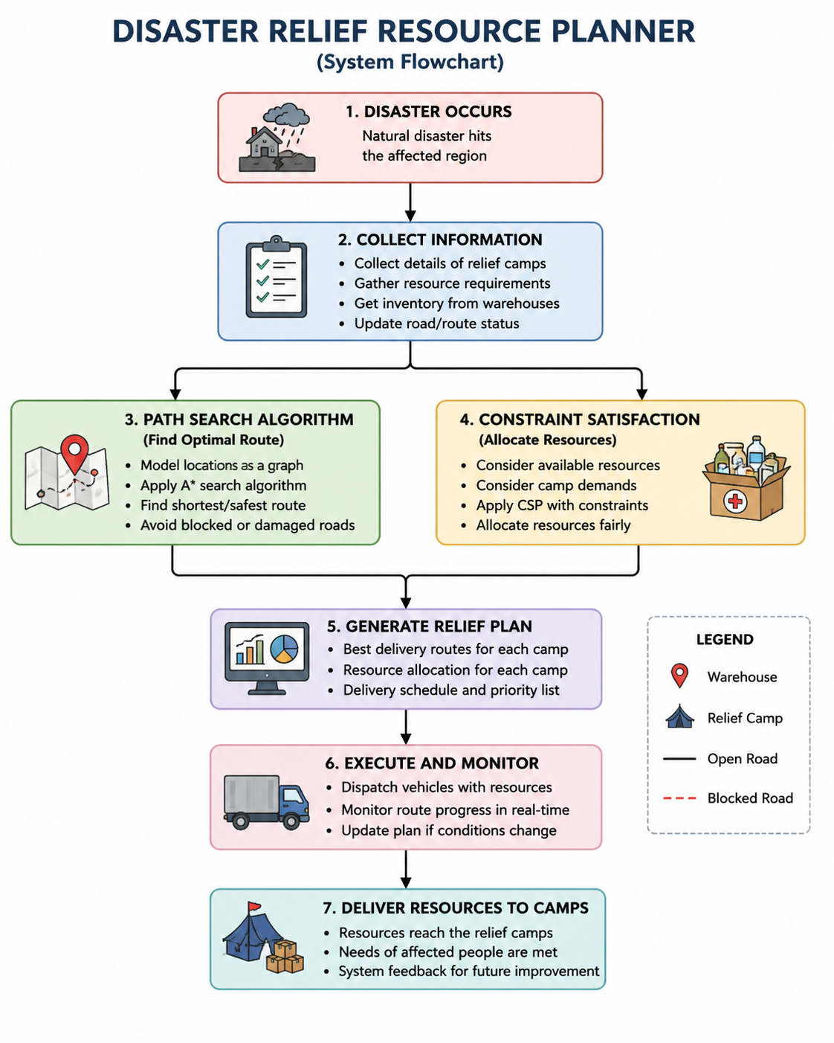

2.Path Search Algorithms for Route Planning
Path Search Algorithms are essential for identifying the most efficient routes for delivering relief supplies during disaster situations. Natural disasters often damage roads, create traffic congestion, and block transportation routes, making it difficult for relief teams to reach affected areas quickly. Selecting the best route is therefore critical for reducing delivery time and ensuring that resources reach people in need as soon as possible.
In this project, warehouses, relief camps, and road networks are represented as nodes and edges in a graph. The system applies the A* (A-Star) Search Algorithm to find the optimal path between a warehouse and a relief camp. A* combines the actual travel cost with an estimated distance to the destination, allowing it to efficiently determine the shortest and most practical route.
The algorithm helps avoid blocked or damaged roads and identifies alternative routes whenever necessary. By minimizing travel distance and transportation costs, the system improves the overall efficiency of disaster response operations. Faster route planning also enables relief agencies to serve more locations within a shorter period.
Path search techniques are widely used in navigation systems, logistics management, robotics, and emergency planning. In disaster management, they provide a reliable and intelligent solution for ensuring timely and effective delivery of relief resources.
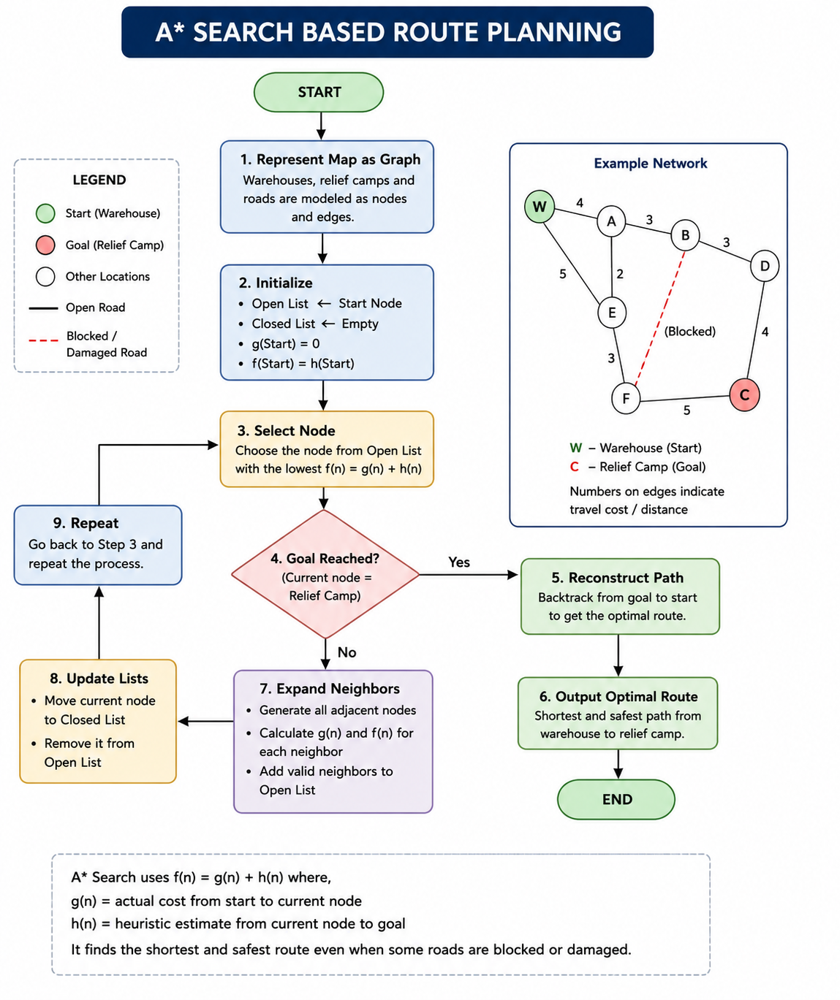

3. Constraint Satisfaction for resource allocation
Constraint Satisfaction Problems (CSP) are used to allocate limited relief resources among multiple camps during disaster situations. In emergencies, the available supply of food, water, medicines, blankets, and other essential items is often insufficient to meet the demands of all affected areas. Therefore, an intelligent allocation strategy is required to ensure fair and efficient distribution.
In this project, each relief camp has specific resource requirements, while warehouses have limited supplies. The system treats resource allocation as a Constraint Satisfaction Problem where the objective is to satisfy as many camp requirements as possible without exceeding the available resources. Constraints such as resource availability, camp priority levels, transportation limits, and minimum resource requirements are considered during the allocation process.
The planner uses CSP techniques to analyze demands and determine the best possible distribution plan. Higher-priority camps, such as those with larger populations or greater damage, may receive resources first while still ensuring that other camps receive essential supplies. This approach helps prevent resource wastage and improves overall disaster response efficiency.
Constraint Satisfaction techniques are widely used in scheduling, planning, timetabling, and resource management applications. In disaster relief operations, they provide a systematic method for distributing limited resources fairly and effectively, ensuring that aid reaches the maximum number of affected people.

Figure: Resource Allocation using Constraint Satisfaction Problem (CSP)
Available Resources
(Food, Water, Medicine)
|
CSP Solver
|
-----------------
| | |
Camp A Camp B Camp C
(High) (Medium) (Low)

4. Challenges in Disaster Relief Planning
Disaster relief operations face several challenges that can affect the timely delivery of essential resources to affected communities. Natural disasters often damage roads, bridges, and communication networks, making transportation and coordination difficult. These disruptions can delay relief efforts and increase the risk faced by disaster victims.
One major challenge is identifying safe and efficient routes when some roads are blocked or inaccessible. Relief teams must quickly adapt to changing conditions and find alternative paths to reach affected areas. Another challenge is the limited availability of resources compared to the high demand from multiple relief camps. Ensuring fair distribution while prioritizing the most critical needs can be a complex task.
Uncertainty is also a significant factor in disaster management. Information about road conditions, camp populations, and resource requirements may change frequently during emergency situations. Poor communication and lack of real-time data can further complicate decision-making processes.
To address these challenges, intelligent planning systems that combine path search algorithms and constraint satisfaction techniques can help optimize route selection and resource allocation. Such systems improve efficiency, reduce response time, and support better decision-making during disaster relief operations.

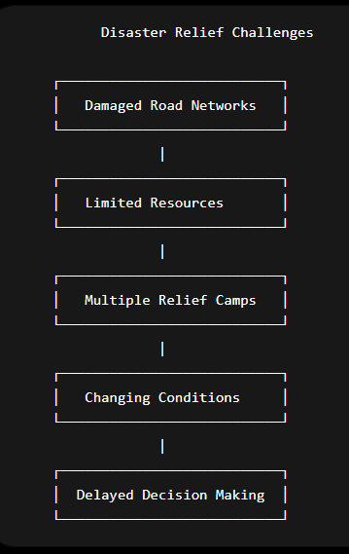

5. Solutions and Optimization Techniques
To overcome the challenges faced during disaster relief operations, the Disaster Relief Resource Planner combines Artificial Intelligence techniques for route optimization and resource allocation. The system is designed to improve decision-making, reduce response time, and ensure effective utilization of available resources.
The first solution involves the use of the A* Search Algorithm for route planning. This algorithm identifies the shortest and most efficient path between warehouses and relief camps while avoiding blocked or damaged roads. By selecting optimal routes, transportation costs and delivery times can be significantly reduced.
The second solution is the application of Constraint Satisfaction Problem (CSP) techniques for resource allocation. The system considers factors such as resource availability, camp demands, priority levels, and transportation limitations. Based on these constraints, resources are distributed fairly and efficiently among all relief camps.
Optimization techniques also help disaster management teams adapt to changing situations. If road conditions change or new relief requests are received, the system can update routes and resource allocations accordingly. This flexibility ensures that relief operations remain effective even in dynamic and uncertain environments.
By integrating path search and constraint satisfaction methods, the planner provides a comprehensive solution for disaster response management. The combination of intelligent route selection and optimized resource distribution improves the overall efficiency and reliability of relief operations.

Figure: Solutions and Optimization Process

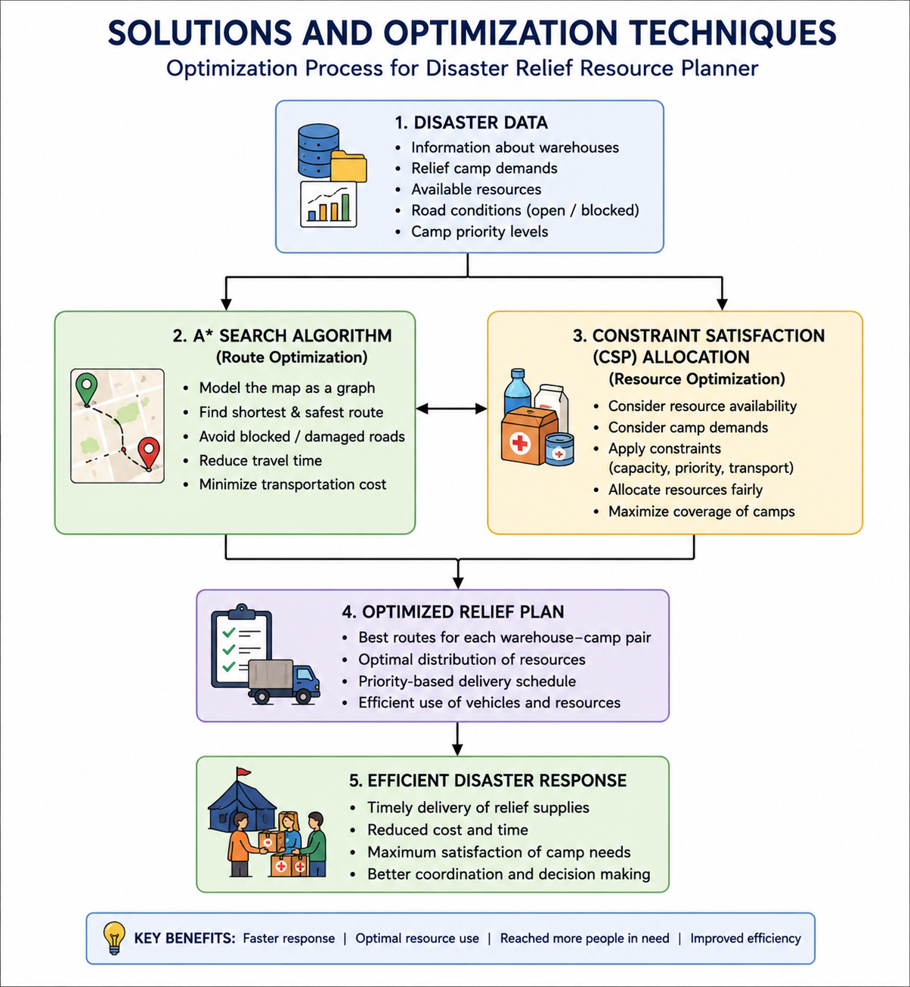

6. Applications
The Disaster Relief Resource Planner has several practical applications in emergency management and humanitarian assistance. The system helps disaster response teams make faster and more effective decisions during natural disasters such as floods, earthquakes, cyclones, landslides, and wildfires. By automating route planning and resource allocation, it improves the efficiency of relief operations and reduces delays in delivering essential supplies.
Government agencies can use the planner to coordinate relief activities across multiple affected regions. Non-governmental organizations (NGOs) and humanitarian agencies can utilize the system to distribute food, water, medicines, and shelter materials based on the needs of different relief camps. The planner can also support military and rescue teams involved in emergency response operations.
Apart from disaster management, the concepts used in this project can be applied to logistics and supply chain management, where efficient transportation and resource distribution are important. Similar techniques can be used in healthcare supply delivery, warehouse management, and emergency medical services.
The integration of path search algorithms and constraint satisfaction methods makes the system a valuable tool for improving coordination, reducing operational costs, and ensuring that aid reaches affected communities quickly and effectively.

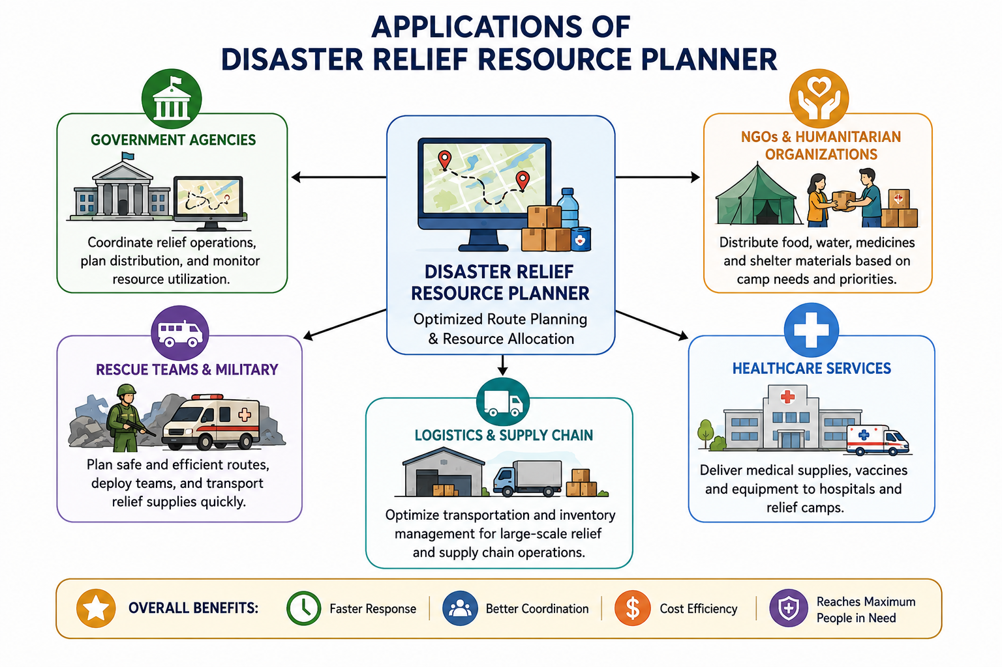

7. Future Scope
The Disaster Relief Resource Planner can be further enhanced by incorporating advanced technologies and real-time data sources to improve its efficiency and accuracy. As disaster management becomes increasingly dependent on intelligent systems, future developments can make the planner more adaptive and capable of handling complex emergency situations.
One possible improvement is the integration of real-time GPS and traffic data to continuously update routes during relief operations. This would help delivery teams avoid newly blocked roads and reach affected areas more quickly. The system can also be connected to weather forecasting services to predict potential risks and support proactive planning.
Machine Learning and Artificial Intelligence techniques can be used to analyze historical disaster data and predict resource requirements for different regions. This would enable authorities to prepare relief supplies in advance and improve overall disaster readiness. Additionally, mobile applications and cloud-based platforms can be developed to allow relief teams to access updated plans from any location.
Future versions of the system may also support drone-based delivery, autonomous vehicles, and IoT-enabled monitoring devices for tracking resources in real time. These technologies can further enhance the speed, accuracy, and effectiveness of disaster response operations.
The continuous development of intelligent planning systems will play an important role in improving humanitarian assistance and ensuring better support for communities affected by natural disasters.
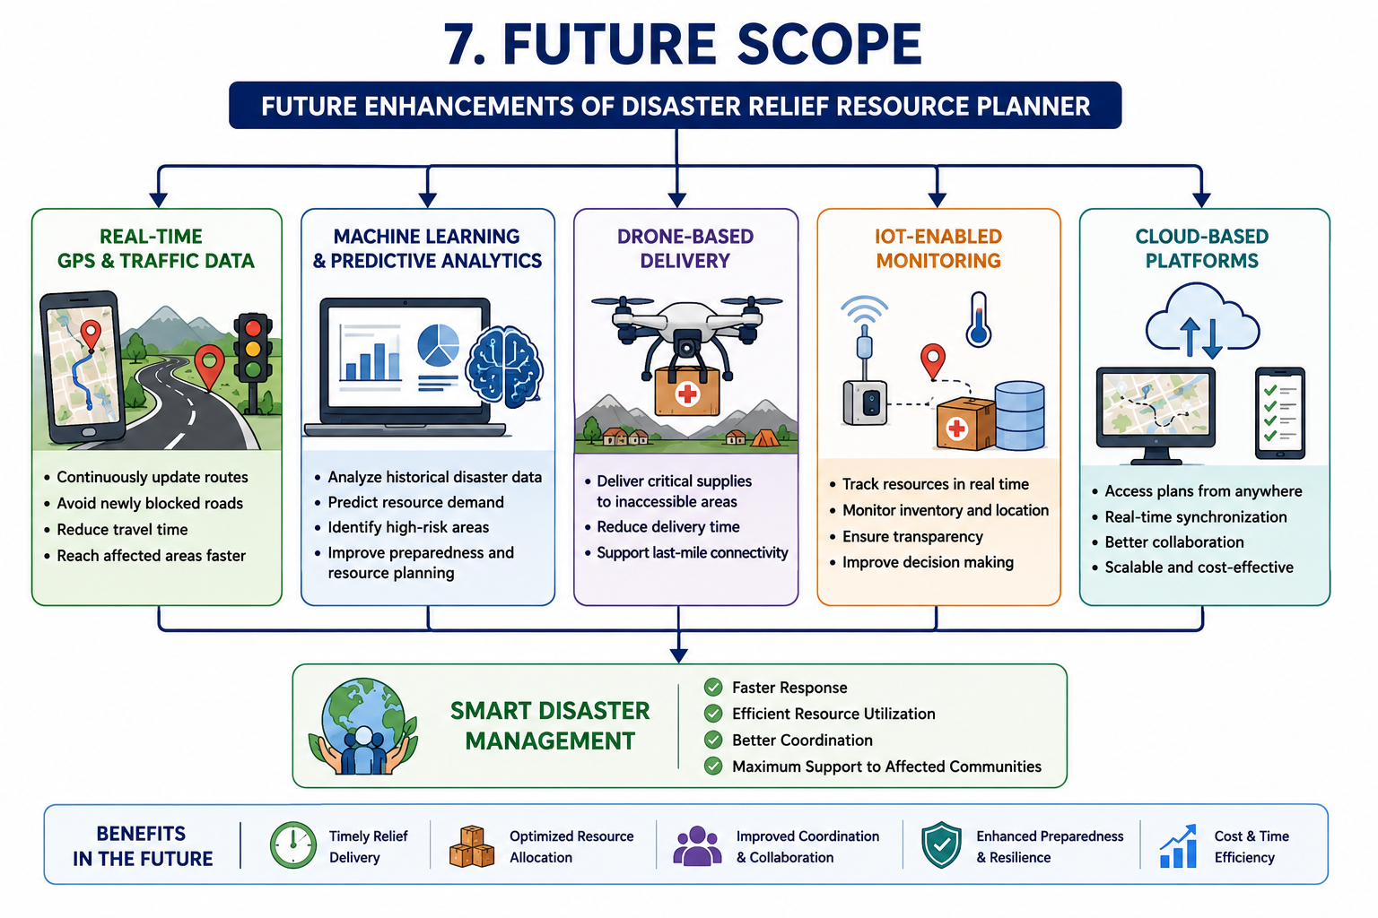

8. Conclusion
The Disaster Relief Resource Planner is an intelligent system designed to improve disaster response through efficient route planning and resource allocation. During emergencies, rapid delivery of essential supplies is crucial for minimizing the impact of disasters and supporting affected communities. The project addresses this challenge by combining Path Search Algorithms and Constraint Satisfaction techniques.
The A* Search Algorithm helps identify the shortest and most efficient routes between warehouses and relief camps, reducing travel time and transportation costs. At the same time, Constraint Satisfaction methods ensure that limited resources such as food, water, medicines, and shelter materials are distributed fairly and effectively among multiple camps.
The system provides a practical application of Artificial Intelligence concepts in disaster management and demonstrates how intelligent planning can improve decision-making during emergency situations. By automating route optimization and resource allocation, the planner increases operational efficiency and helps relief agencies respond more effectively.
Future advancements such as real-time data integration, machine learning, drone-based delivery, and cloud platforms can further enhance the capabilities of the system. Overall, the Disaster Relief Resource Planner offers a reliable and scalable solution for supporting humanitarian relief operations and improving disaster preparedness.
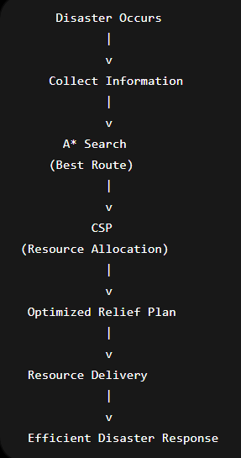

9. References
•Stuart Russell and Peter Norvig, Artificial Intelligence: A Modern Approach, Pearson Education.
• Elaine Rich and Kevin Knight, Artificial Intelligence, McGraw-Hill Education.
• Nils J. Nilsson, Artificial Intelligence: A New Synthesis, Morgan Kaufmann Publishers.
• Course materials and lecture notes for Computational Foundations for Artificial Intelligence (CFAI).
• Tutorials and documentation on A* Search Algorithm and graph-based pathfinding techniques.
• Educational resources on Constraint Satisfaction Problems (CSP) and resource allocation methods.
• IEEE articles and online journals related to Artificial Intelligence applications in disaster management.
• Government disaster management reports and humanitarian logistics resources.
• Online learning resources on Artificial Intelligence, Search Algorithms, and Problem Solving Techniques.
• Open educational resources and technical articles related to disaster relief planning and
optimization.

